**D.Y Patil College of Engineering, Akurdi**

MINI PROJECT REPORT

Title: Material Study and CAE of Chassis

Group No: 28

Division: B

Prepared by :

Rewa Gandhi (TEMEB21226)

Kalash Pratapwar (TEMEB21224)

Sanchita Ramapure (TEMEB2123) Prajwal Charde (TEMEB21225)

Under The Guidance Of :- Mr.Sargar Wangdare

**Introduction:**

Chassis is the main support structure of the vehicle which is also known as ‘Frame’. It bears all the stresses on the vehicle in both static and dynamic conditions. In a vehicle, it is analogues to the skeleton in living organism . The origin of chassis lies in the French Language . Every vehicle whether it is a two wheeler or a car or a truck has a chassis frame. However, its form obviously varies with the vehicle type.

**Abstract:**

Chassis is a major component of a vehicle system. It consists of internal framework that supports man-made object. It is the underpart of the vehicle which consists of frame and running gear like engine, transmission system, suspension system etc. Modelling of the chassis is done through a advanced

CAD/CAM/CAE software Unigraphics. The design and analysis of the chassis is done by identifying the location of high stress areas. chassis has been designed in a way to reduce vibration, increase strength and optimize the weight of the chassis.

**Types of Chassis**:

# A) Ladder- Ladder frame construction, is a common motor vehicle construction method, whereby a separate body or coach is mounted on a strong and relatively rigid vehicle frame or chassis that carries different subsystems

B) Tubular-Multi interconnecting tubes that provide strength for multidirectional support on tubular steel is known as space frame structure

C) Monocoque A type of vehicle construction (as of an automobile) in which the body is integral with the chassis — compare space frame, unibody.

D) Backbone- It is a strong tubular backbone connects the front and rear axle and provides very high mechanical strength. The whole drive train, suspension, engine are connected to both the ends of backbone.

**Material Selection:**

|  |  |  |  |  |  |  |
| --- | --- | --- | --- | --- | --- | --- |
| **Material** | **Modulas**  **of elasticity** | **Yield**  **Strength** | **Thickness** | **Outside Diameter** | **Stiffness** | **Strength** |
| AISI1018 | 205 | 365 | 3 | 31.4 | 1170.82 | 164.144 |
| AISI4340 | 205 | 649.7 | 3 | 31.4 | 2786.1 | 604.7 |
| AISI1010 | 205 | 649.7 | 3 | 31.4 | 1170.82 | 292.117 |
| AISI4130 | 205 | 649.7 | 3 | 31.4 | 1410.74 | 352.04 |

During Material selection, we found that the bending strength and bending stiffness of the above materials when compared with each other on same cross sections AISI 4130 results into being the best material among the group. This is a theoretical approach but the main results are taken from test report.

**Material Analysis wrto Mechanical properties:**

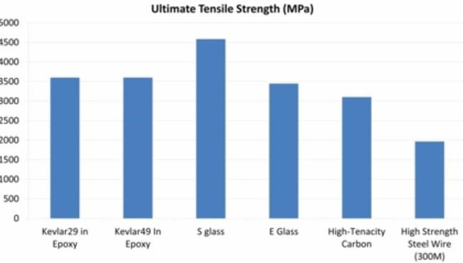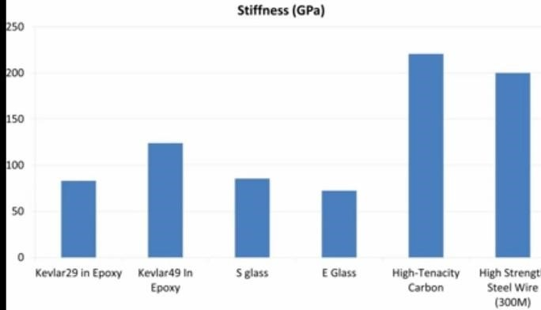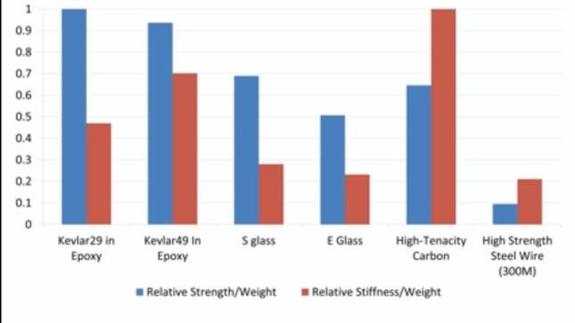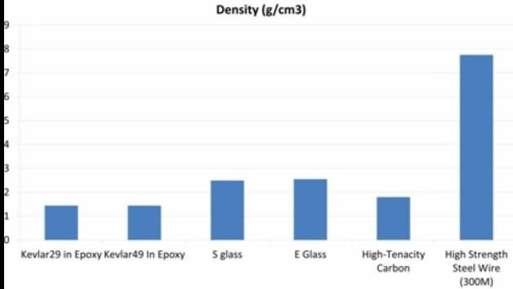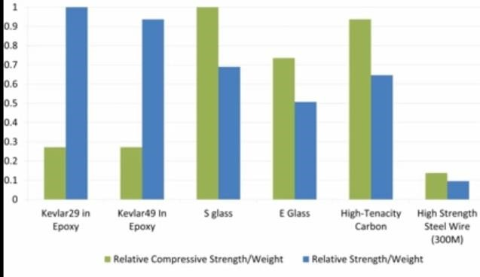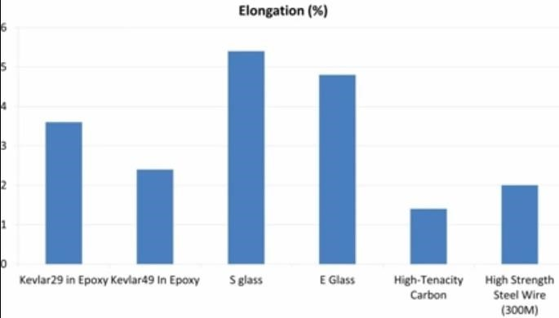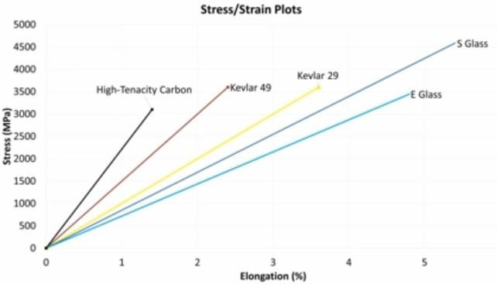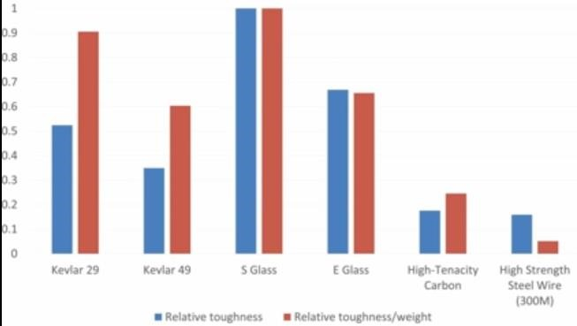

So after comparing all the above graphs carbon fibre is clearly dominating in all the properties and is the best suitable material for manufacturing

**Carbon Fibre analysis**

* Carbon Fiber has High Strength to Weight Ratio (also known as specific strength
* Carbon Fiber is very Rigid
* Carbon fiber is Corrosion Resistant and Chemically Stable
* Carbon fiber is Electrically Conductive
* Fatigue Resistance is good
* Carbon Fiber has good Tensile Strength
* Low Coefficient of Thermal Expansion

**CAE Of Chassis**

**CAD Model**

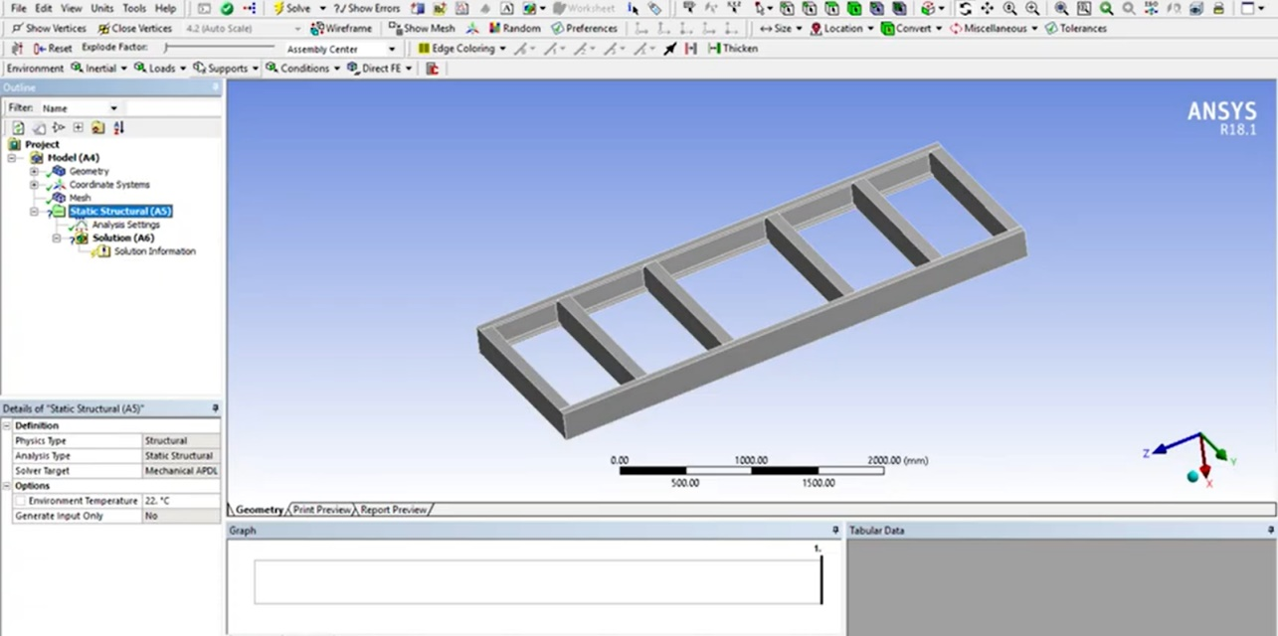

**Static structural analysis:**

1. Equivalent Elastic strain

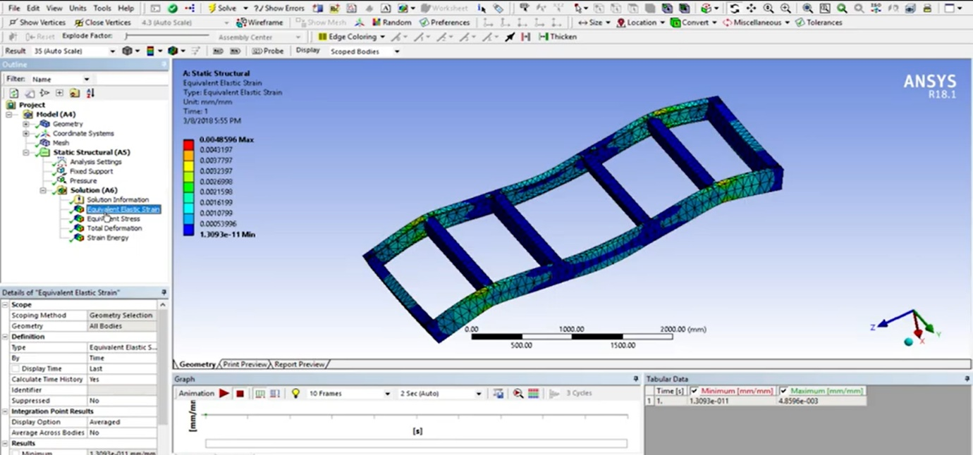

1. Equivalent stress

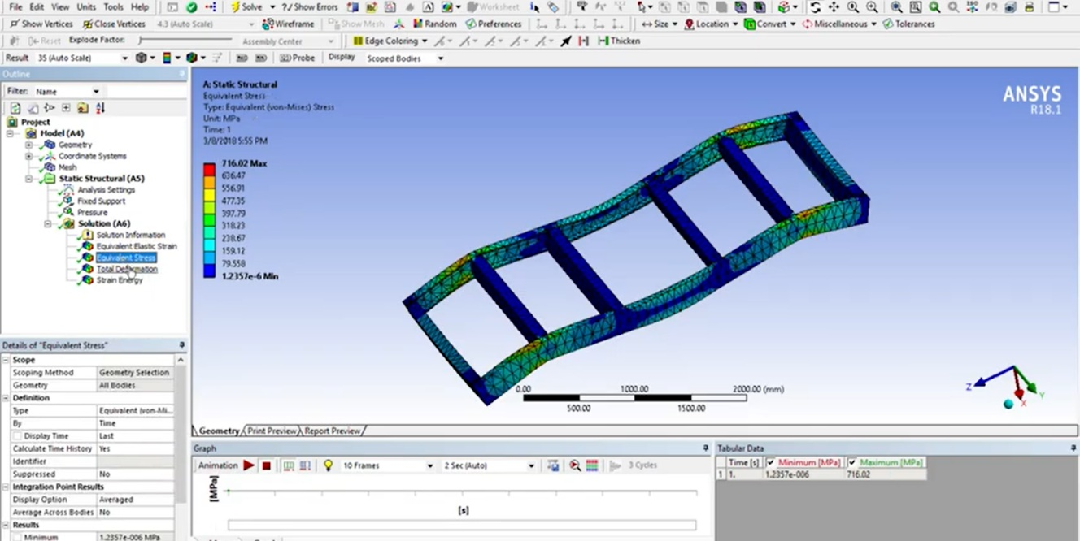

1. Total Deformation

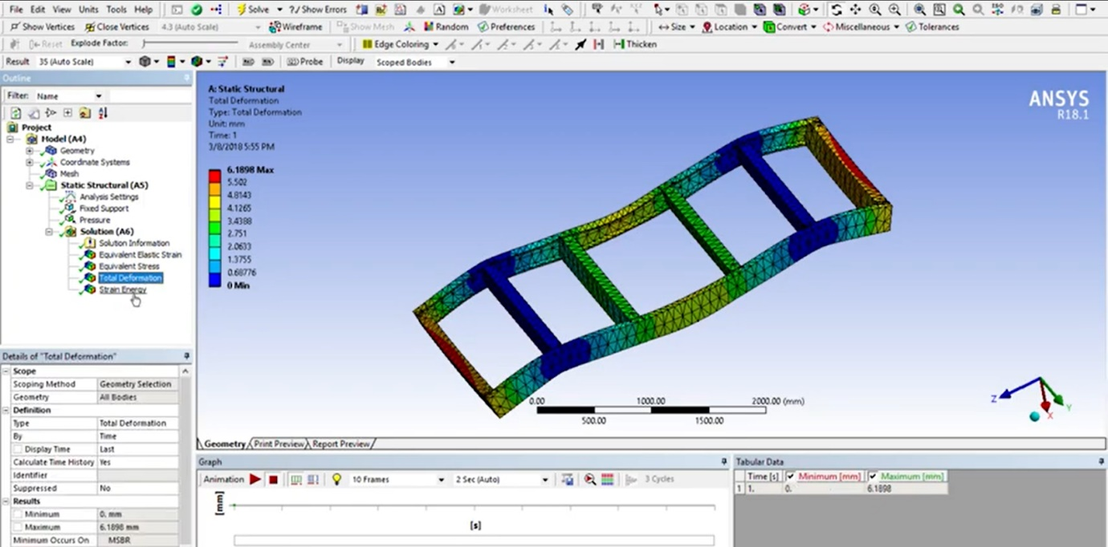

1. Strain energy

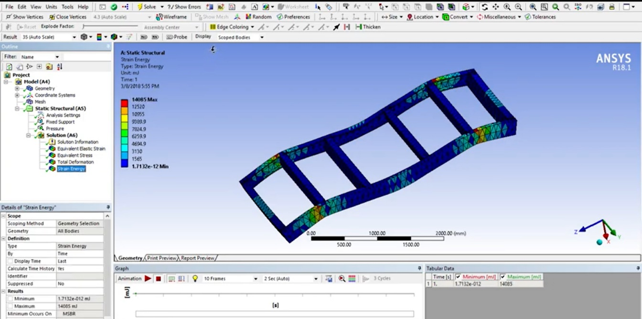

**Modal Analysis**

1)Frequency 1

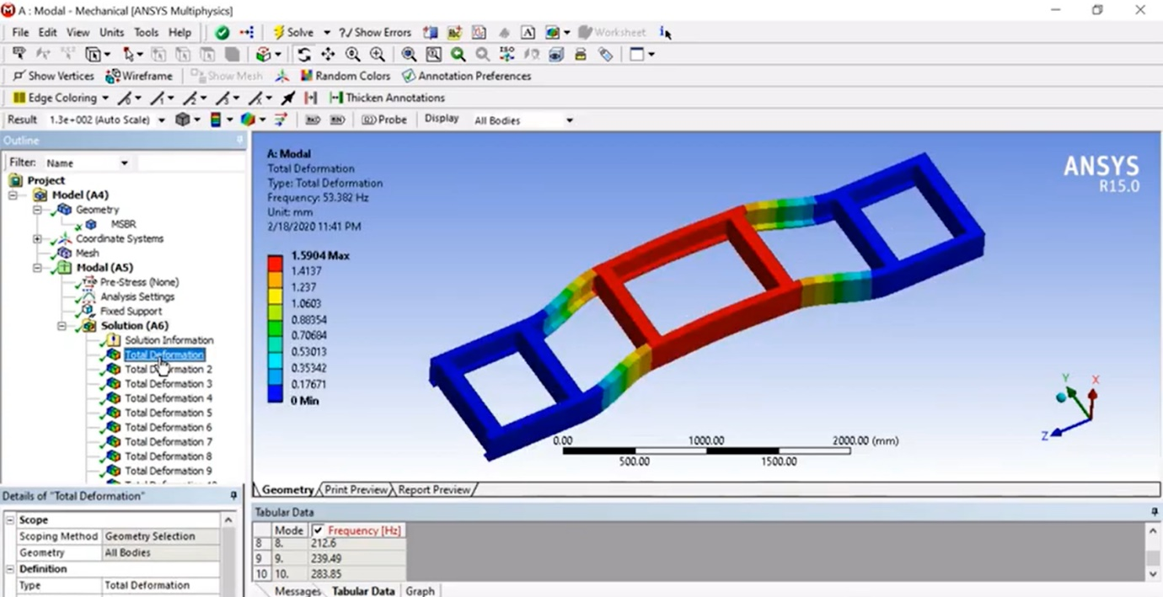

2)Frequency 2

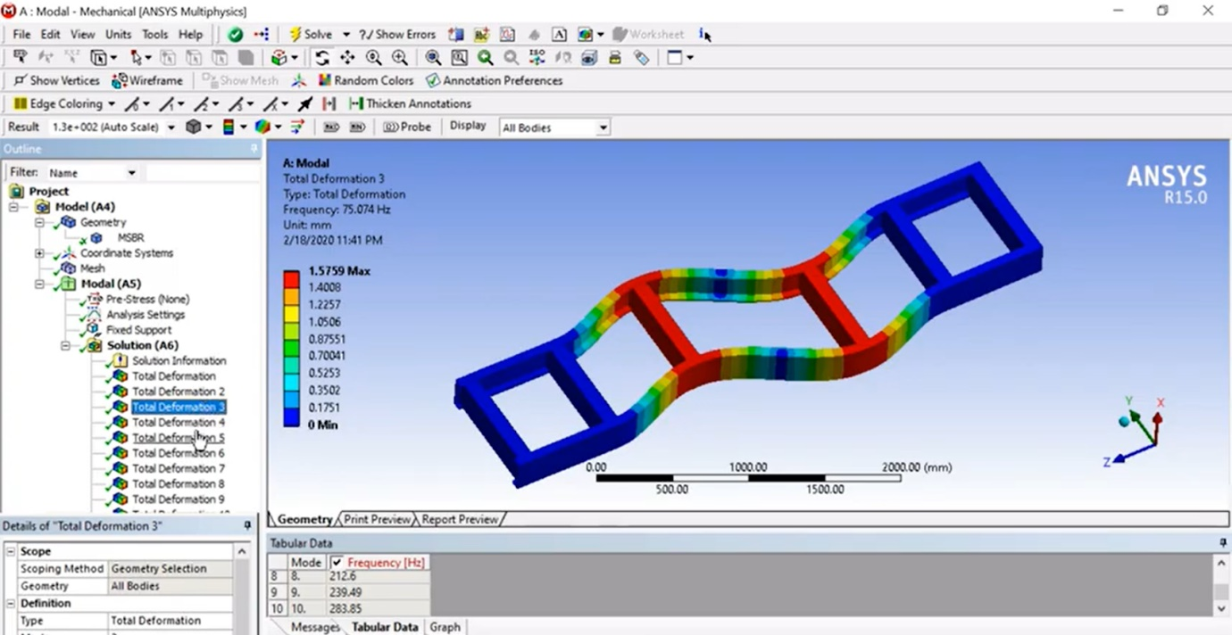

3)Frequency 3

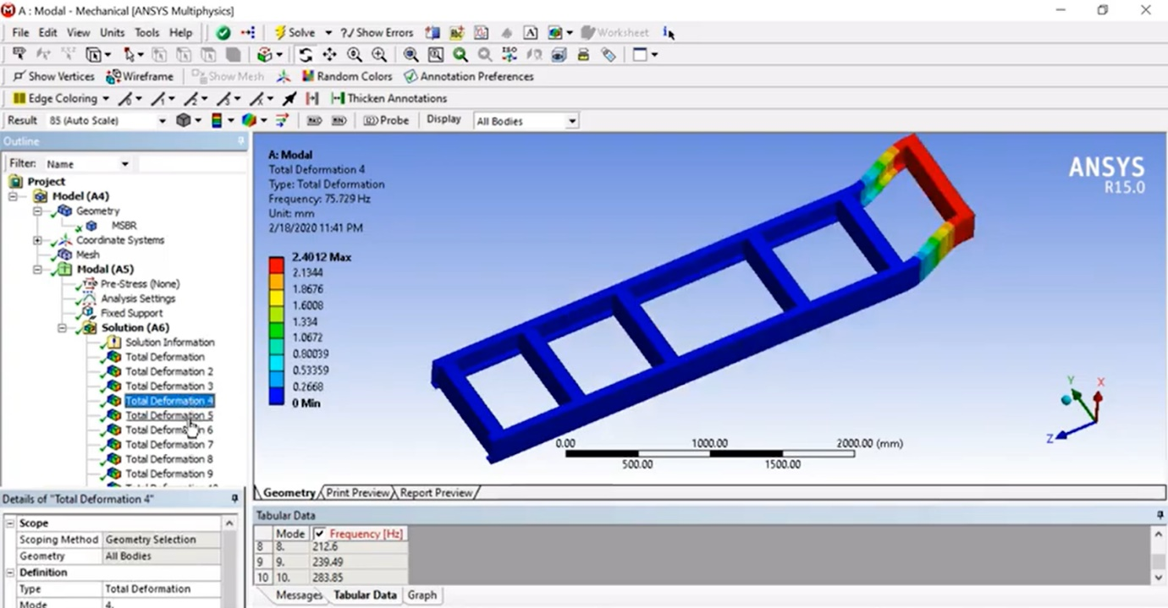

**Conclusion**

From the above report we conclude the understanding of entire method for material selection and Computational design became the most important part of the process by using CAE software we were able to print our ideas before constructing any prototype.